**Arktos and Mizar Single Node Installation Guide**

## **Date: 3 Jan 2022**

## **Introduction**

This document is intended for new users to install the Arktos platform with Mizar as the underlying network technology.

## **Installation Steps**

* Prepare lab machine, the preferred OS is **Ubuntu 18.04**. If you are using AWS, the recommended instance size is t2.2xlarge and the storage size is 128GB or more

cd

git clone https://github.com/CentaurusInfra/mizar.git

cd mizar

chmod 755 setup-machine-arktos.sh

./setup-machine-arktos.sh

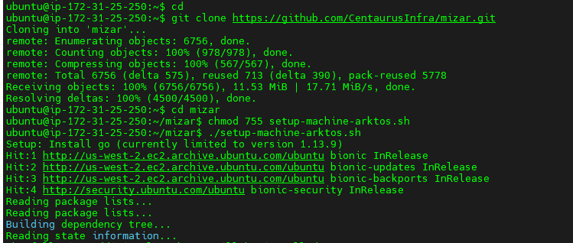

The lab machine will be rebooted once the above script is completed, you will be automatically logged out of the lab machine.

* Log onto your lab machine, then run bootstrap.sh script from the Mizar project folder to bootstrap your lab machine.
* Once bootstrap is completed, you can then compile Mizar. Make sure to run these in sudo mode:

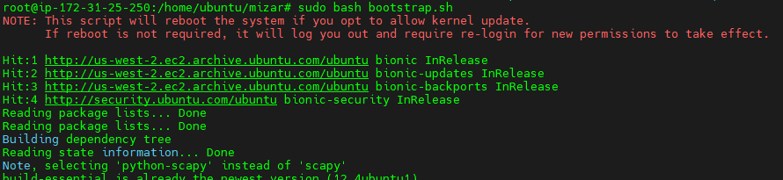

cd ~/mizar

sudo su

make

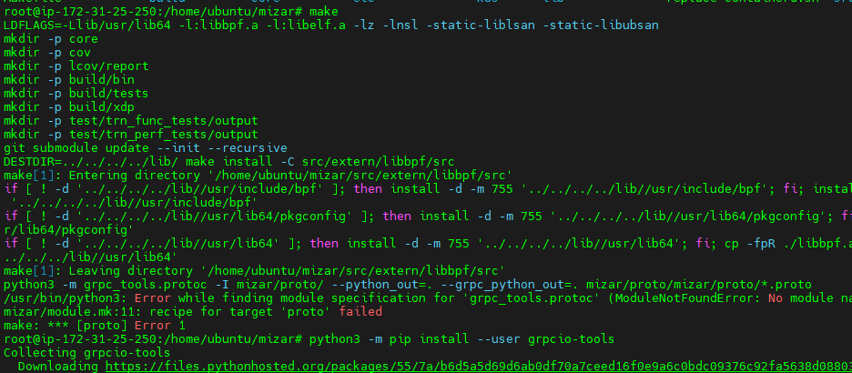

***Install grpcio tools:***

python3 -m pip install --user grpcio-tools

make

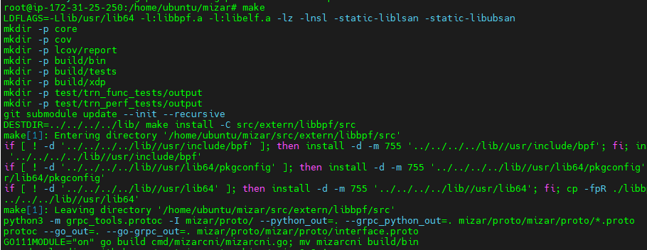

**Build arktos-network-controller (as it is not part of arktos-up.sh yet)**

cd $HOME/go/src/k8s.io/arktos

sudo ./hack/setup-dev-node.sh

make all WHAT=cmd/arktos-network-controller

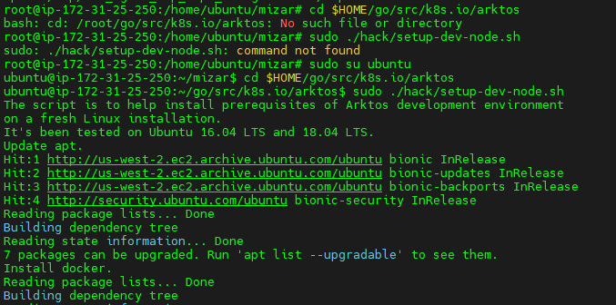

Also, please ensure the hostname and its ip address in /etc/hosts. For instance, if the hostname is ip-172-31-25-250, ip address is 172.31.25.250:

127.0.0.1 localhost

172.31.25.250 ip-172-31-25-250

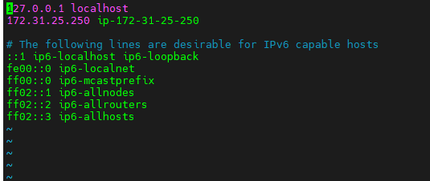

**Replace the Arktos containerd:**

cd $HOME/mizar

sudo bash replace-containerd.sh

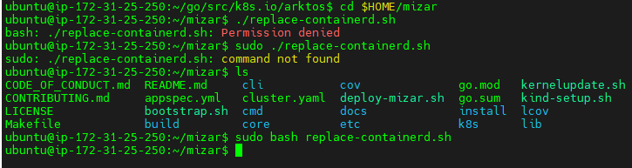

**Before deploying Mizar, you will need first start up Arktos API server:**

cd $HOME/go/src/k8s.io/arktos

./hack/arktos-up.sh

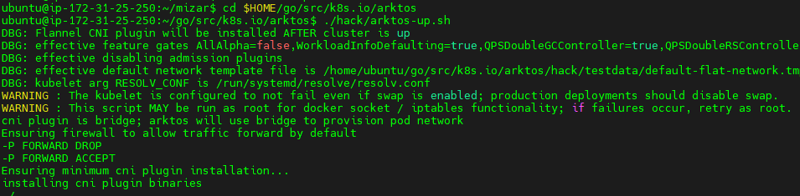

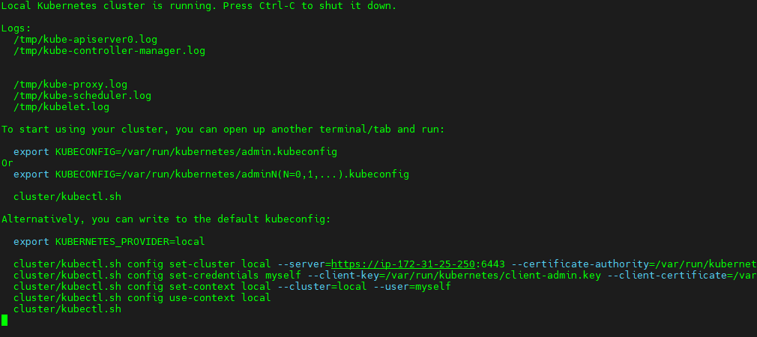

**Deploy Mizar. Open a new terminal window, and run:**

cd $HOME/mizar

./deploy-mizar.sh

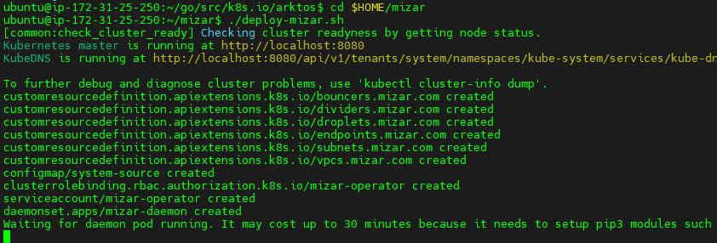

**Once your arktos server and Mizar are running. To verify, you can open a new terminal and run kubectl get nodes, you should see a node running with the name starts with "IP" followed by the private IP address of your lab machine.**



You also want make sure the default kubernetes bridge network configuration file is deleted:

sudo ls /etc/cni/net.d

sudo rm /etc/cni/net.d/bridge.conf

**Start Arktos network controller. From a new terminal window, run:**

cd $HOME/go/src/k8s.io/arktos

./_output/local/bin/linux/amd64/arktos-network-controller --kubeconfig=/var/run/kubernetes/admin.kubeconfig --kube-apiserver-ip=xxx.xxx.xxx.xxx

where the kube-apiserver-ip is your lab machine's **private ip address**

